4. UML Class Diagram
The classes below were derived from the user stories in Section 2 and from the actors and use cases in Section 3. Method names reuse the Function column of the backlog so that the three models remain consistent and the design can be implemented directly in Part 2. The subsections follow the five criteria of the marking scheme: classes, fields, methods, relationships and multiplicity.

4.1 The class diagram
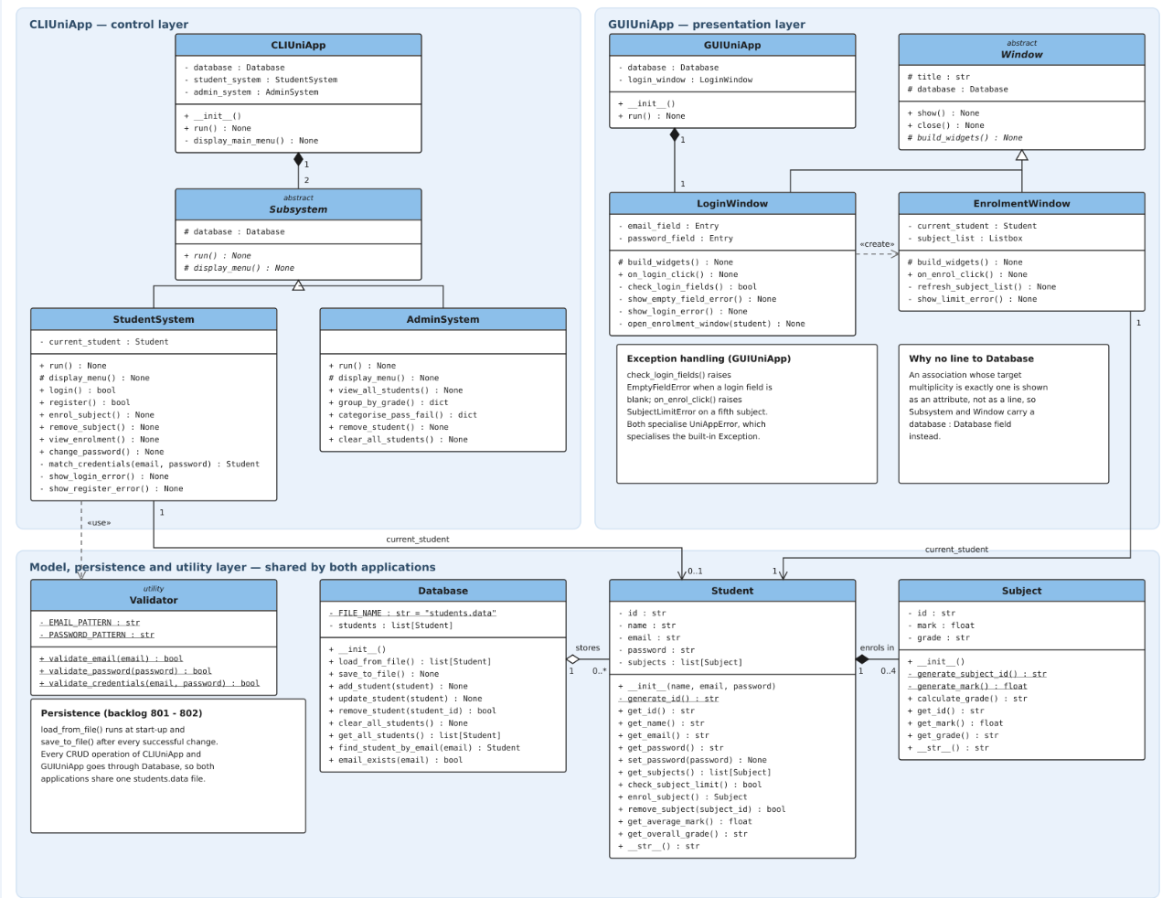
Figure 4.1 UML class diagram of CLIUniApp and GUIUniApp

4.2 Classes
Class | Layer | Responsibility
Student | Model | A registered student. Owns the enrolment list and enforces the four-subject rule, so the same rule holds for both applications without being written twice.
Subject | Model | One enrolled subject. Generates its own three-digit id and random mark and derives the grade, because the brief states the student does not choose a subject.
Database | Persistence | The only class that reads and writes students.data. Concentrating file access here is what makes all CRUD operations use the single file.
Validator | Utility | Applies the email and password patterns defined in the brief. Stateless, so it is never instantiated.
CLIUniApp | Control | Entry point of the command-line application. Creates the Database and the two subsystems and shows the main menu.
Subsystem (abstract) | Control | Common structure of a menu-driven subsystem: the shared database reference and the two operations every subsystem must supply.
StudentSystem | Control | The student subsystem: login, register, enrol, remove a subject, view the enrolment list and change password.
AdminSystem | Control | The admin subsystem: view all students, group by grade, categorise PASS/FAIL, remove a student and clear the file.
GUIUniApp | Presentation | Entry point of the graphical application (challenge task).
Window (abstract) | Presentation | Common structure of a window: title, database reference, show() and close().
LoginWindow | Presentation | The main window. Authenticates the student and opens the enrolment window.
EnrolmentWindow | Presentation | Displays the enrolment list and handles the Enrol action.
UniAppError | Exception | Common ancestor of the application errors; specialises the Python built-in Exception.
EmptyFieldError | Exception | Raised when a login field is left blank.
SubjectLimitError | Exception | Raised on an attempt to enrol in a fifth subject.

4.3 Fields and visibility
Class | Fields | Vis. | Reason for the visibility
Student | id, name, email, password, subjects | - | Set at registration and afterwards changed only through set_password(), enrol_subject() and remove_subject().
Subject | id, mark, grade | - | All three are produced by the object itself and must never be assigned from outside.
Database | students | - | The in-memory record list is reachable only through the CRUD methods.
Database | FILE_NAME | - static | The file name belongs to the class rather than to an instance and never changes.
Validator | EMAIL_PATTERN, PASSWORD_PATTERN | - static | The patterns are fixed rules of the class; Validator holds no instance state.
Subsystem | database | # | Protected so StudentSystem and AdminSystem inherit the same Database reference.
Window | title, database | # | Protected so both windows inherit them.
StudentSystem | current_student | - | Held only between a successful login and the return to the main menu.
CLIUniApp, GUIUniApp | database, subsystem and window references | - | Objects the application owns; not part of any interface it offers.
LoginWindow, EnrolmentWindow | widget references, current_student | - | Interface states that no other class may reach.

4.4 Methods
Methods are named after the Function column of Section 2. A method that returns a value is typed with what it returns; a method that performs an action and returns nothing is typed None. Public methods form the interface a class offers to others, private methods only support an operation of the same class, and the three abstract operations are implemented by every subclass.
Kind | Examples | Returns | Vis.
Constructor | Student. __init__(name, email, password), Subject.__init__() | — | +
Accessor / mutator | get_id(), get_mark(), set_password(password) | field type / None | +
Business rule | check_subject_limit(), calculate_grade(), enrol_subject(), remove_subject(subject_id) | bool / str / Subject / bool | +
Generator | generate_id(), generate_subject_id(), generate_mark() | str / str / float | - static  (no object is needed and the value must not be reassigned)
Persistence | load_from_file(), save_to_file(), remove_student(student_id) | list[Student] / None / bool | +
Validation | validate_email(email), validate_password(password), validate_credentials(email, password) | bool | + static
Interface operation | login(), register(), view_enrolment(), group_by_grade(), on_login_click() | bool / None / dict | +
Error message | show_login_error(), show_register_error(), show_empty_field_error(), show_limit_error() | None | - (triggered internally, matching the <<extend>> use cases of Section 3)
Abstract operation | run(), display_menu(), build_widgets() | None | + / # (implemented by each subclass)

4.5 Relationships
Relationship | Type | Justification
Student — Subject | Composition | A Subject is created by the act of enrolling and has no meaning once the student record is deleted, so the two lifetimes are bound together and the multiplicity at the composite end is exactly one.
Database — Student | Aggregation | Database groups the student records for the duration of a session, but they live in students.data and outlive any Database object, so the part is not owned by the whole.
CLIUniApp — Subsystem | Composition | The application creates and owns both subsystems; they are destroyed with it.
GUIUniApp — LoginWindow | Composition | The login window is the main window of GUIUniApp and is created with it.
StudentSystem, AdminSystem — Subsystem | Generalization | Both are subsystems: they inherit the database field and implement run() and display_menu(). Neither adds a field the other lacks, so the 100% rule holds.
LoginWindow, EnrolmentWindow — Window | Generalization | Both share a title, a database reference, show() and close().
StudentSystem —> Student | Association, role current_student | The subsystem holds the student it is acting for, from a successful login until the return to the main menu.
EnrolmentWindow —> Student | Association, role current_student | The window always operates on one authenticated student.
StudentSystem --> Validator | Dependency <<use>> | Validator is never instantiated, so the calling class holds no object reference; the weaker dependency is correct rather than an association.
LoginWindow --> EnrolmentWindow | Dependency <<create>> | The enrolment window is created only after authentication succeeds. Dependency carries no multiplicity.
Subsystem, Window — Database | Shown as an attribute | An association whose target multiplicity is exactly one is not worth drawing, so the shared Database appears as the protected database field of Subsystem and Window instead of as a line.
EmptyFieldError, SubjectLimitError — UniAppError — Exception | Generalization | The two errors GUIUniApp must handle specialize one project error class, which specializes the built-in Exception. They are recorded in the note on Figure 4.1 so that the figure stays readable.

4.6 Multiplicity
Relationship | Multiplicity | Reason
Student — Subject | 1 to 0..4 | A subject belongs to exactly one student. A student holds none at first and at most four, so the multiplicity states the four-subject limit in the model itself.
Database — Student | 1 to 0..* | students.data may be empty or hold any number of registered students.
CLIUniApp — Subsystem | 1 to 2 | The brief requires exactly two subsystems, one for students and one for admins.
GUIUniApp — LoginWindow | 1 to 1 | The application owns exactly one main window.
StudentSystem — Student | 1 to 0..1 | No student object is held before a login succeeds, and exactly one afterwards.
EnrolmentWindow — Student | 1 to 1 | The enrolment window is only ever opened for one authenticated student.

